|  |  |
| --- | --- |
| Name | Umar Hayyat |
| Roll No | 2019-EE-360 |

**Transistor as a Switch**

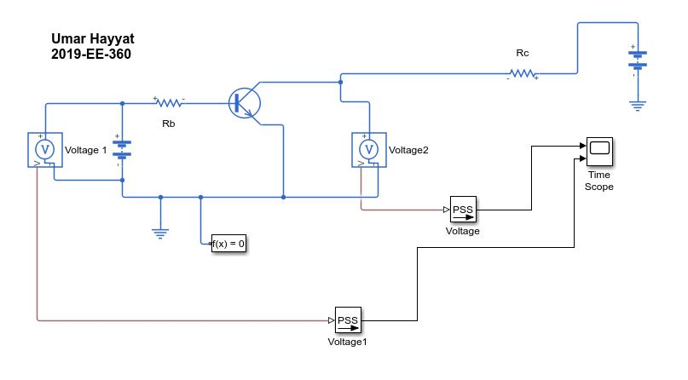

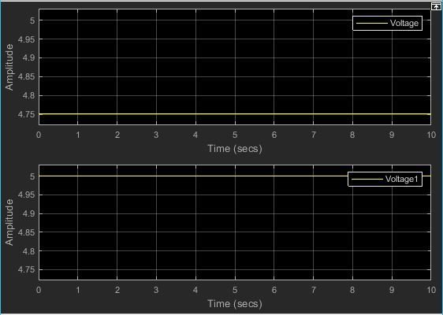

**Darlington transistor**

